**BYOB HAPPY HOUR**

Every Friday 5-7 PM

in the Community Room

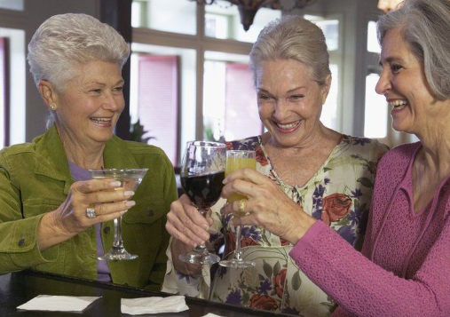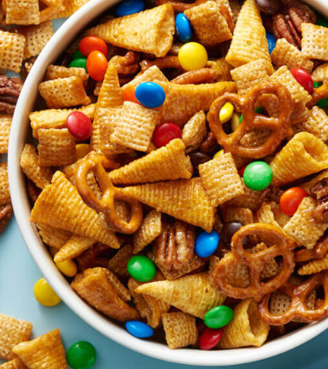

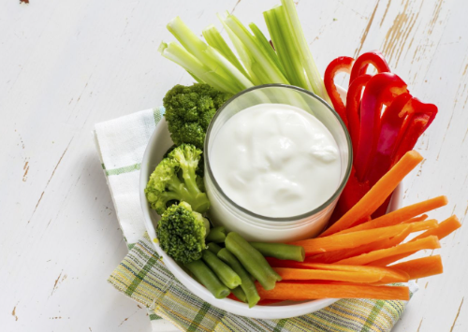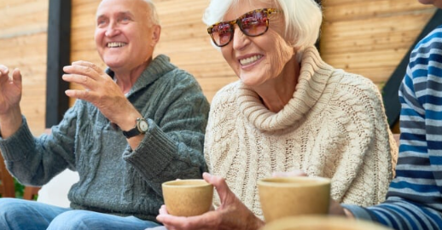

Meet new People – Make New Friends

**Bring a snack to share if you’d like.**